How does the Dobryy Sokil work?
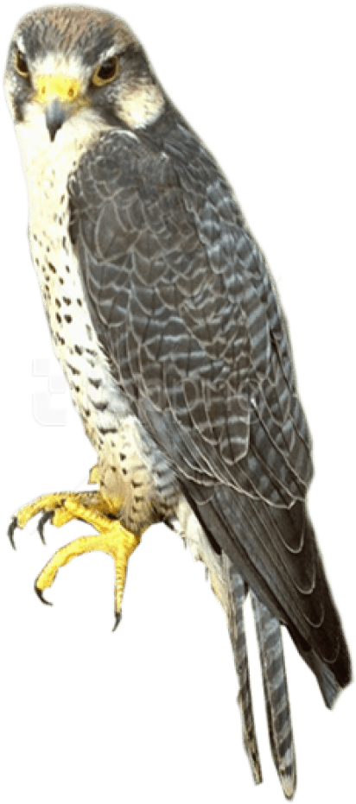
- Its Ears : Listen to the Owner’s commands : Perimeter and Object of search (the Prey), and then transmit them to the Brain

- Its Wings:
- Make the animal flying and then positioning itself above the previously communicated Perimeter of search, guided by the Brain;
- Make it possible for the animal to swoop down on the prey;
- Make it possible for the animal to bring the grabbed prey to its owner after a successful hunt.

- Eyes: Visualize the whole Perimeter probably containing the wanted Prey and then transmit all the information obtained to the Brain

- Brain:
- Computes all the information obtained from the eyes and also from the ears in order to deduce the Prey’s coordinates within the Parameter;
- Validates the swooping down action on the prey to be grabbed;
- Commands all the set of members making up the animal

- Claws: Grab the prey.

